Exercise 7
1. List the names of 5 youngest employees in the company.
SELECT f_name, l_name FROM employee_data ORDER BY age ASC LIMIT 5;
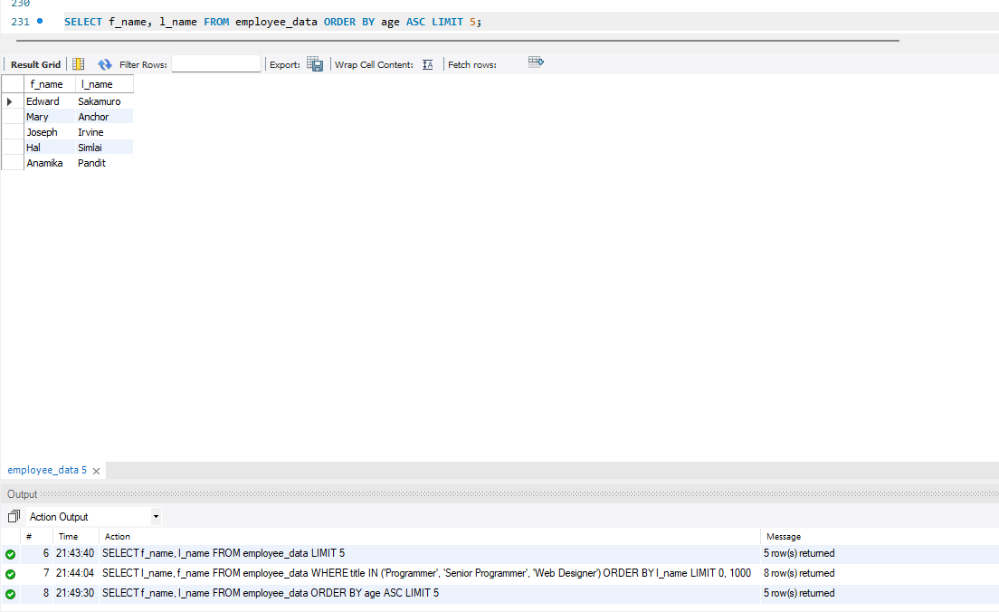
2. Extract the next 5 entries starting with the 10th row.
SELECT f_name, l_name FROM employee_data LIMIT 9,5;
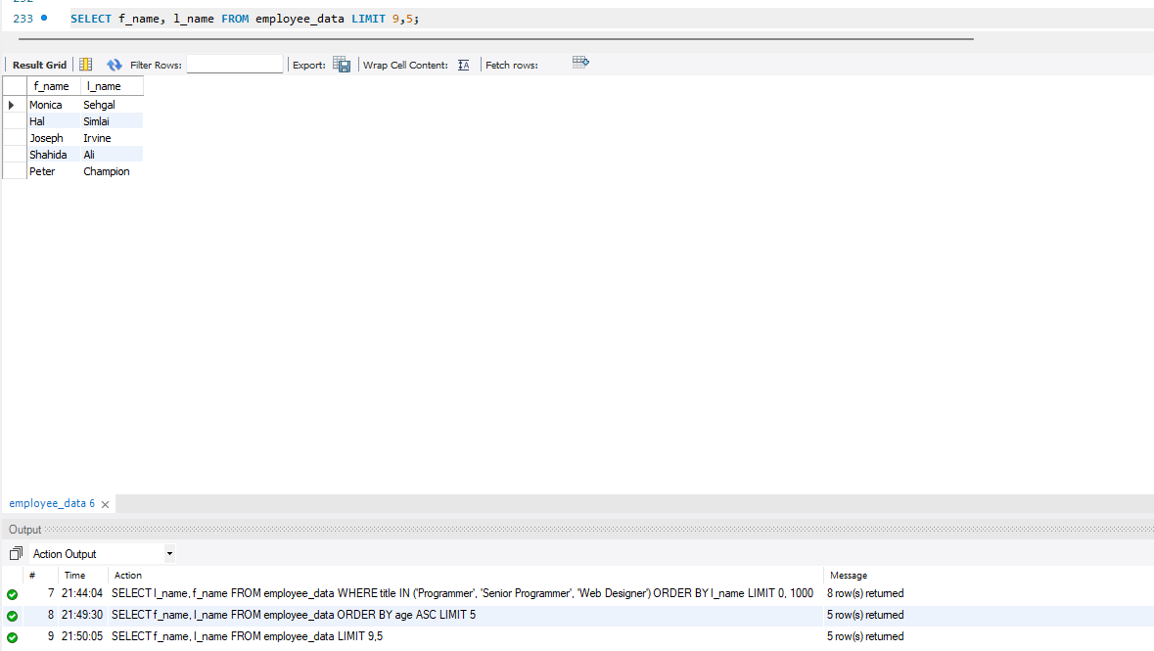

3. Display the names and salary of the employee who draws the largest salary.
SELECT f_name, l_name, salary FROM employee_data ORDER BY salary DESC LIMIT 1;
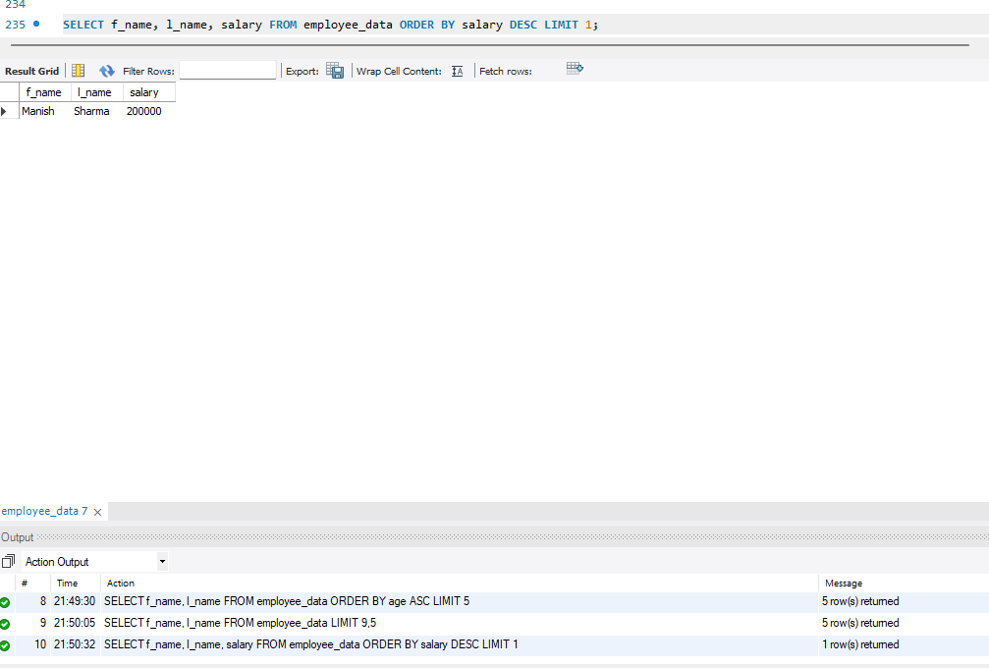
4. What does the following statement display?
SELECT emp_id, age, perks FROM employee_data ORDER BY perks DESC LIMIT 10;
